GNS3 Project Report

A Multi-Department University Network Design with web design app to watch the devices
------------------------------------------------------------------------------

Submitted By:
Name: ISAM MUWHAID, MOSAB BASHEER
Student ID: 12505049 , 12400328

------------------------------------------------------------------------------

Supervised By:
- Eng. Ibrahim Fathi Mahmoud Amria
- Dr. Jihad Mahmoud Amin Hamamra
Tools & LINKS
Download the virtualbox, gns3 and Ubuntu to use it from the links :
virtualbox : https://www.virtualbox.org/wiki/Downloads
Ubuntu : https://ubuntu.com/download/desktop
c3745 cisco: https://lomboknetworking.blogspot.com/p/cisco-ios-gns3.html
gns3 download tutorial: https://drive.google.com/file/d/19FCvb2lVvpcIOS_42x4EyjqWsJ4ZU__2/view
This project presents the design and implementation of a multi-department university network using GNS3. The network simulates a real-world campus environment where multiple faculties are interconnected through a central router.

Objectives
- Design a hierarchical campus network
- Connect multiple departments using routers
- Configure IP addressing for all devices
- Implement static routing between networks
- Verify connectivity using ICMP testing

Topology Description
The network consists of a main router that acts as the core of the network, connecting two faculty routers. Each faculty router is connected to a switch, which provides connectivity to end devices within that department.
1. Drag
3 Router (Cisco 3745)
2 switchs
4 vpcs
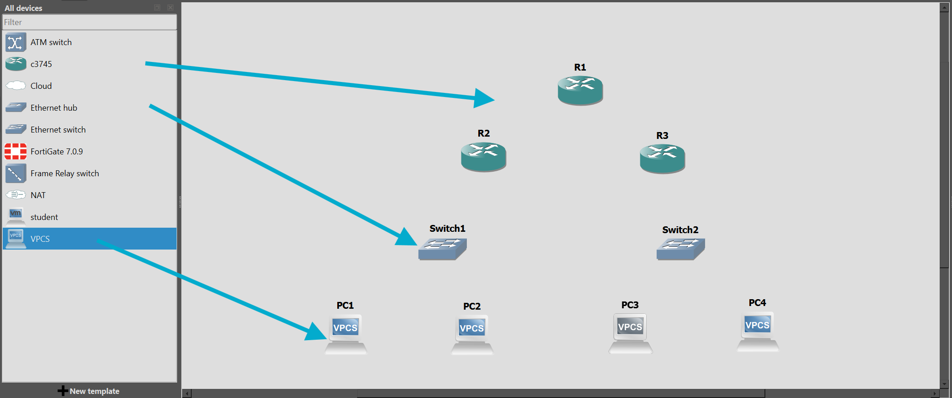
press on the cable I icon and connect the devices in this form :
Device | Interface | Connected To | Interface
Main Router (R1) | FastEthernet0/0 | Faculty-A Router (R2) | FastEthernet0/0
Main Router (R1) | FastEthernet0/1 | Faculty-B Router (R3) | FastEthernet0/0

Device |  |  | Interface | Connected To | Interface
Faculty-A Router (R2) |  |  | FastEthernet0/1 | Switch-A | Ethernet0
PC-A1 |  |  | Ethernet0 | Switch-A | Ethernet1
PC-A2 |  |  | Ethernet0 | Switch-A | Ethernet2

Device | Interface | Connected To | Interface
Faculty-B Router (R3) | FastEthernet0/1 | Switch-B | Ethernet0
PC-B1 | Ethernet0 | Switch-B | Ethernet1
PC-B2 | Ethernet0 | Switch-B | Ethernet2
Make sure it fit :
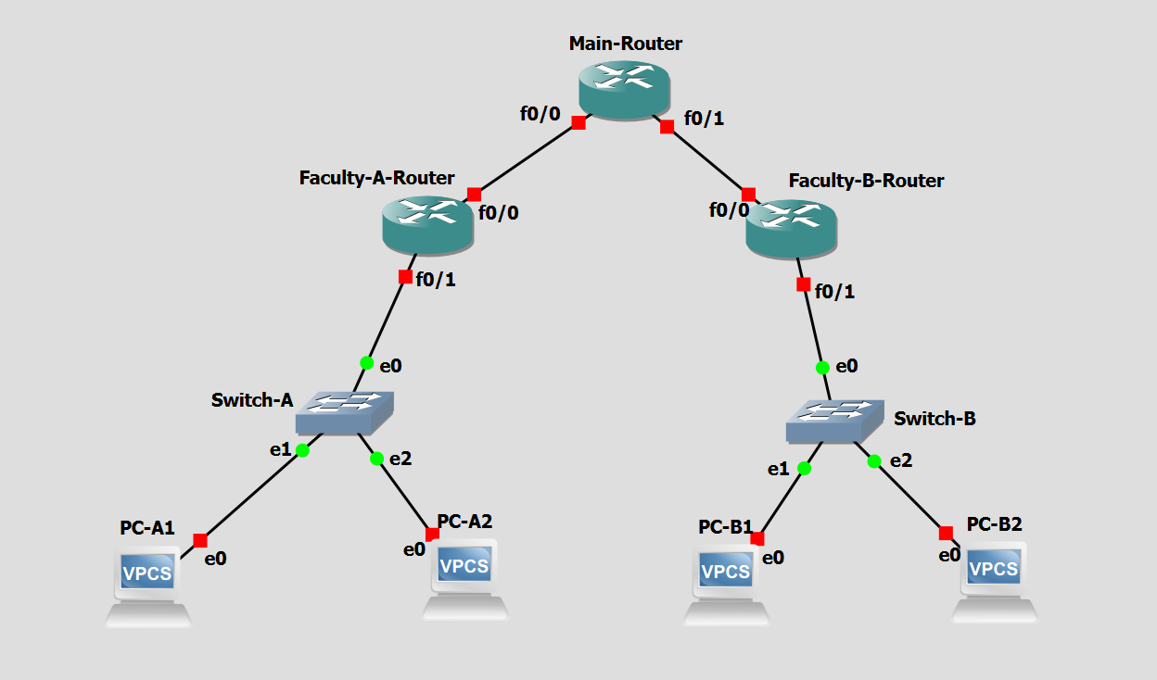
Now, we will give ip to each router to let the network start working :
1. Start the network with the green button : 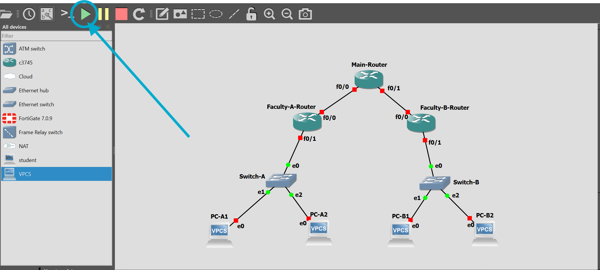
then right click the main – router and press on console :
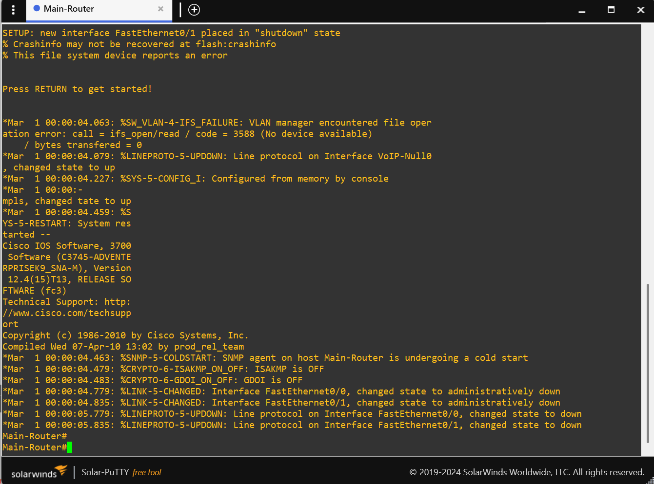
copy the following command and right click in the main router to paste :
enable
configure terminal
interface fa0/0
ip address 10.0.12.1 255.255.255.252
no shutdown
interface fa0/1
ip address 10.0.13.1 255.255.255.252
no shutdown
end
copy the following command and right click in R2 (Faculty A) to paste :
enable
configure terminal
interface fa0/0
ip address 10.0.12.2 255.255.255.252
no shutdown
interface fa0/1
ip address 192.168.10.1 255.255.255.0
no shutdown
end
copy the following command and right click in R3 (Faculty B) to paste :
enable
configure terminal
interface fa0/0
ip address 10.0.13.2 255.255.255.252
no shutdown
interface fa0/1
ip address 192.168.20.1 255.255.255.0
no shutdown
end
now commands of the pc :
copy the following command and right click in PC-A1to paste :
ip 192.168.10.10/24 192.168.10.1
copy the following command and right click in PC-A1to paste :
ip 192.168.10.20/24 192.168.10.1
copy the following command and right click in PC-B1 to paste :
ip 192.168.20.10/24 192.168.20.1
copy the following command and right click in PC-B2 to paste :
ip 192.168.20.20/24 192.168.20.1
THEN TEST BY TYPING IN PC-A1 :
ping 192.168.10.1
ping 192.168.10.20
AND THEN TEST IN PC-B1 :
ping 192.168.20.1
ping 192.168.20.20
now connect the two routers together by opening the console of main router and pasting :
enable
configure terminal
ip route 192.168.10.0 255.255.255.0 10.0.12.2
ip route 192.168.20.0 255.255.255.0 10.0.13.2
end
write memory
THEN PASTE IN Faculty-A-Router :
enable
configure terminal
ip route 192.168.20.0 255.255.255.0 10.0.12.1
end
write memory
THEN PASTE IN Faculty-B-Router :
enable
configure terminal
ip route 192.168.10.0 255.255.255.0 10.0.13.1
end
write memory
THEN PASTE IN Faculty-B-Router :
enable
configure terminal
ip route 192.168.10.0 255.255.255.0 10.0.13.1
end
write memory
You can test the project by using this command to test interfaces to be up/up :
show ip interface brief
You can test the project by using this command to test show ip route in routers also:
show ip route
network testing by pinging :
Source Device | Destination IP | Purpose | Expected Result
PC-A1 | 192.168.10.1 | Test connection to gateway | Success
PC-A1 | 192.168.10.20 | Test communication within Faculty A | Success
PC-B1 | 192.168.20.1 | Test connection to gateway | Success
PC-B1 | 192.168.20.20 | Test communication within Faculty B | Success
Inter-Faculty Connectivity (Between Faculties) :
Source Device | Destination IP | Purpose | Expected Result
PC-A1 | 192.168.20.10 | Test communication with Faculty B (PC1) | Success
PC-A1 | 192.168.20.20 | Test communication with Faculty B (PC2) | Success
PC-B1 | 192.168.10.10 | Test communication with Faculty A (PC1) | Success
PC-B1 | 192.168.10.20 | Test communication with Faculty A (PC2) | Success
PART TWO (optinal) OF THE PROJECT ( THE WATCHER ) DEVICE MANUAL :
make a virtual machine (Ubuntu) give it 5rams + 40 storage or less if you can.
setup the virtual machine so you build the watcher website and everything inside of it
When you finish upon terminal in Ubuntu by pressing (Ctrl + Alt + T) or opening it manually
ADD the vm you just made by pressing (ctrl + shift + p) go to vmware then add the THE WATCHER VM
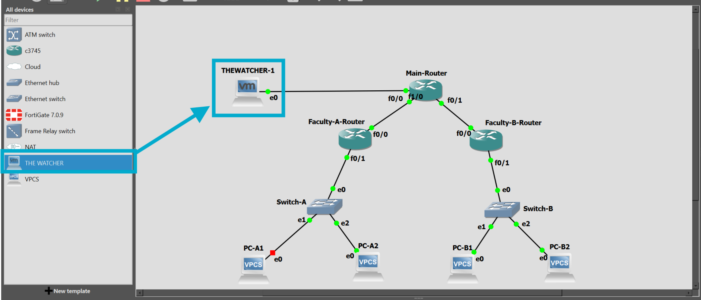
When you finish upon terminal in Ubuntu by pressing (Ctrl + Alt + T) or opening it manually
write this commands for updates :
sudo apt update
sudo apt upgrade –y
Then download the tools we will use for python + pip :
sudo apt install python3 python3-pip -y
Then download flask tool to build the webpage :
pip3 install flask
Then download network tools :
sudo apt install iputils-ping net-tools –y
Make sure the network is working by using :
ip a
ping 8.8.8.8
if you have this problem when using (pip3 install flask) do the following :
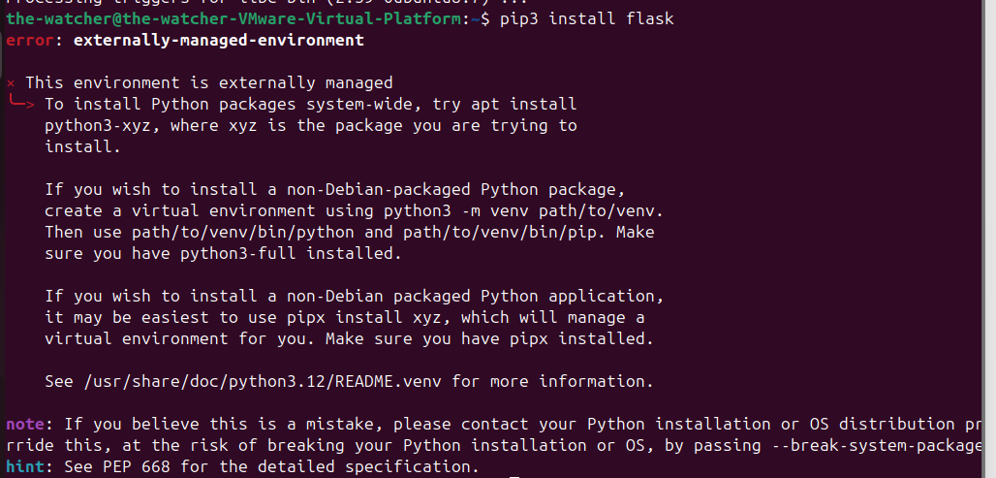
(pip3 install flask) fix :
1. Download venv :
sudo apt install python3-venv –y
2. Make a virtual monitor :
python3 -m venv monitor-env
3. Turn on one of them :
source monitor-env/bin/activate
4. Download flask when you finish writing it you should see (monitor-env) :
pip install flask
5. To test :
pip list
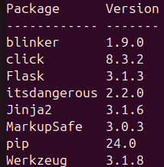
Now type in terminal, make sure that you are in (source monitor-env/bin/activate) :
nano app.py
( very importanttt )Now you should go to my github webpage and read the (manual.readme) and (>>>>>) and do what it is asked there and then come back here :
GITHUB link :
after you finish installing the VM and linking the routes and everything to, go to terminal and make sure that you are inside of ( source monitor-env/bin/activate ) then start the webpage or the app by using ( python app.py )
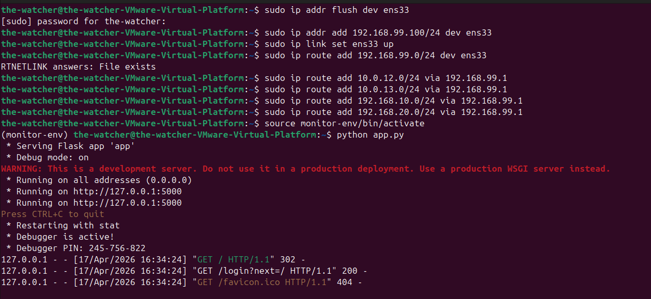
NOTE : If it is your first time to open to get the users passwords and usernames you should open ( http://127.0.0.1:5000/init ) because its not manual in maybe some time later it will get an a upgrade
open ( http://127.0.0.1:5000 ) and you will see the wepage :
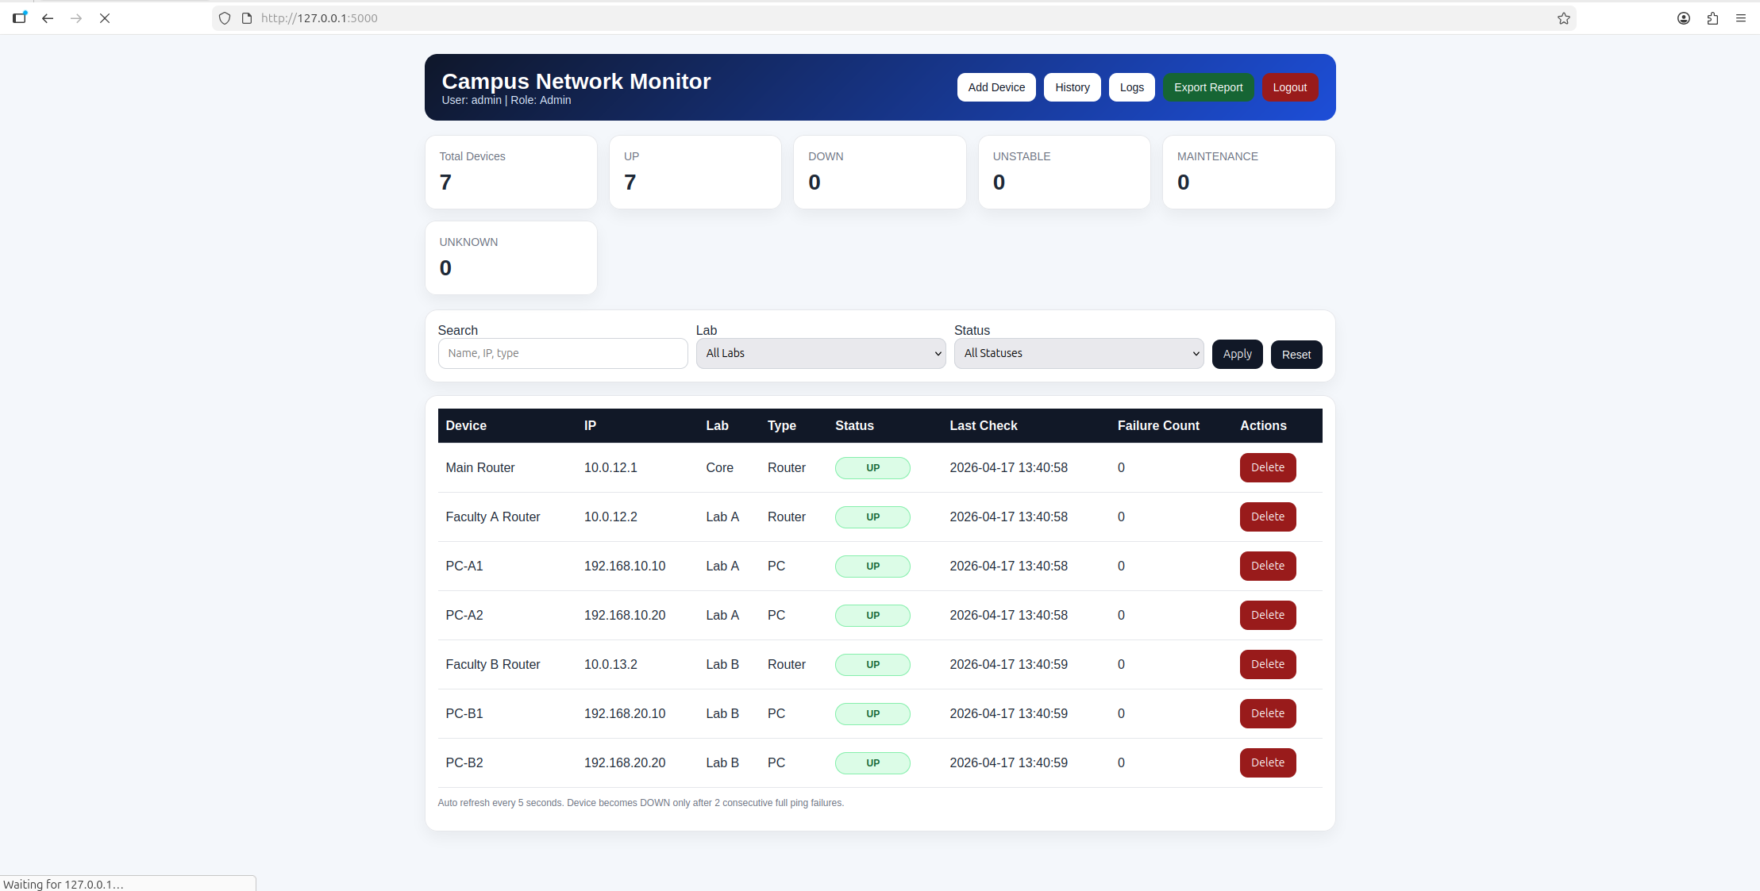
This is the admin view, you can add devices if you want to expand your topology for later and it have history and logs .
tools that can be used to help you create useful networks :
GNS3
flask ) Flask-Login , Flask-SQLAlchemy, Werkzeug, python )
taskade – ai
CISCO IOS
VPCS
Database
Linux (Ubuntu VM)
VMware
Concepts Used :
IP Addressing
Subnetting
Static Routing
Default Gateway
Client-Server Model
Network Monitoring
and more information’s in the presentation (for the problems we faced you can go to the next page.
Problems we faced that you may hit or get in :
THE VNET/HYPER problem when using the gns3vm, you can solve it by :
1.1-open virtual machine settings
1.2-open processors then turn off the check box of :
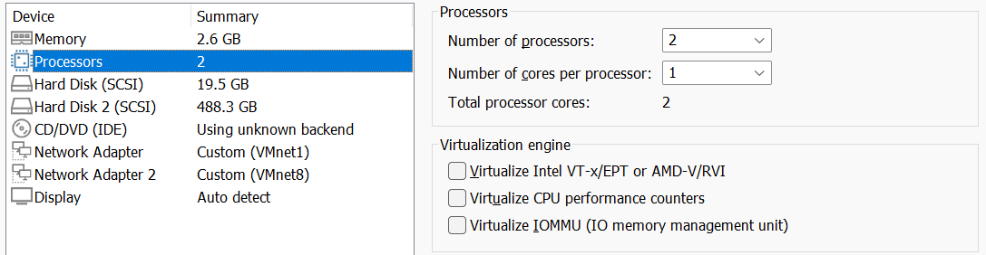
1.3- open the gns3 press )CTRL + SHIFT + P )
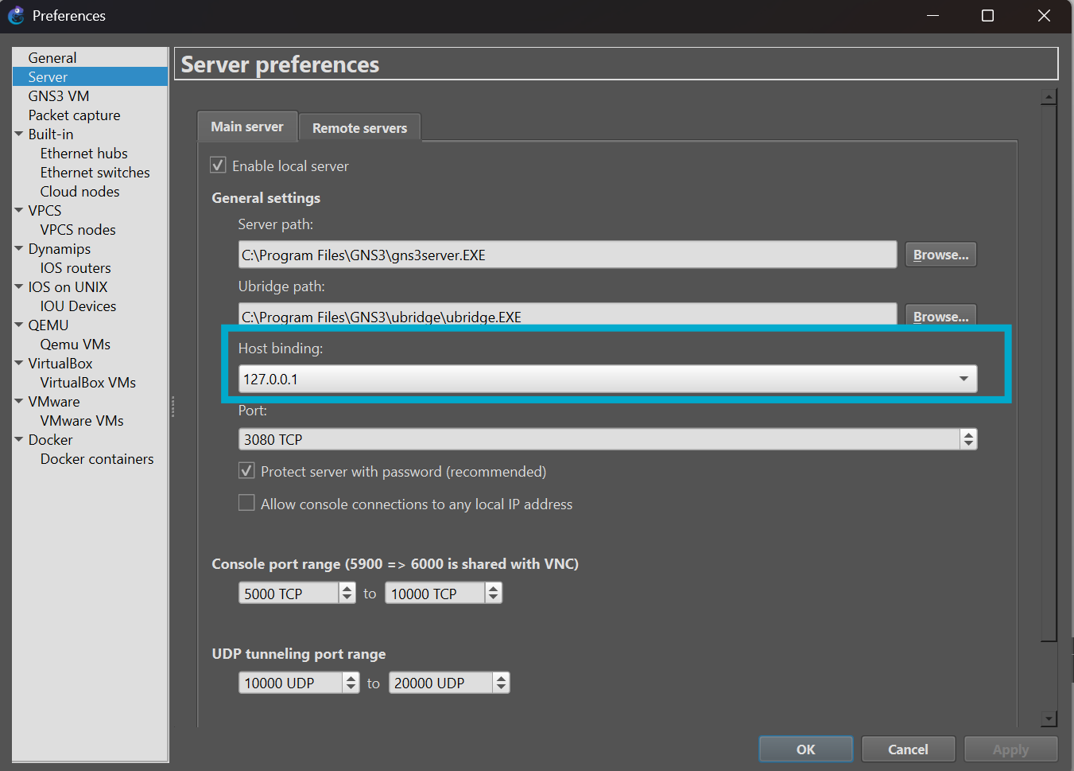
2- Zabbix, not working at all having problem to get data and store it to view the stats of the devices, so we used flask and build a website using AI ( Claude 3.5 sonne ) because of the time we don’t have a better option so we goes with it .
3-The switches my friend, mosab has a punch of problems in gns3 so we where forced to work on my pc ( isam saed ), we have a huge problem with switches that we cant solve so we just workaround replacing switches with routers due to compatibility issues (facilty a-b routers) that you can see in the topology :
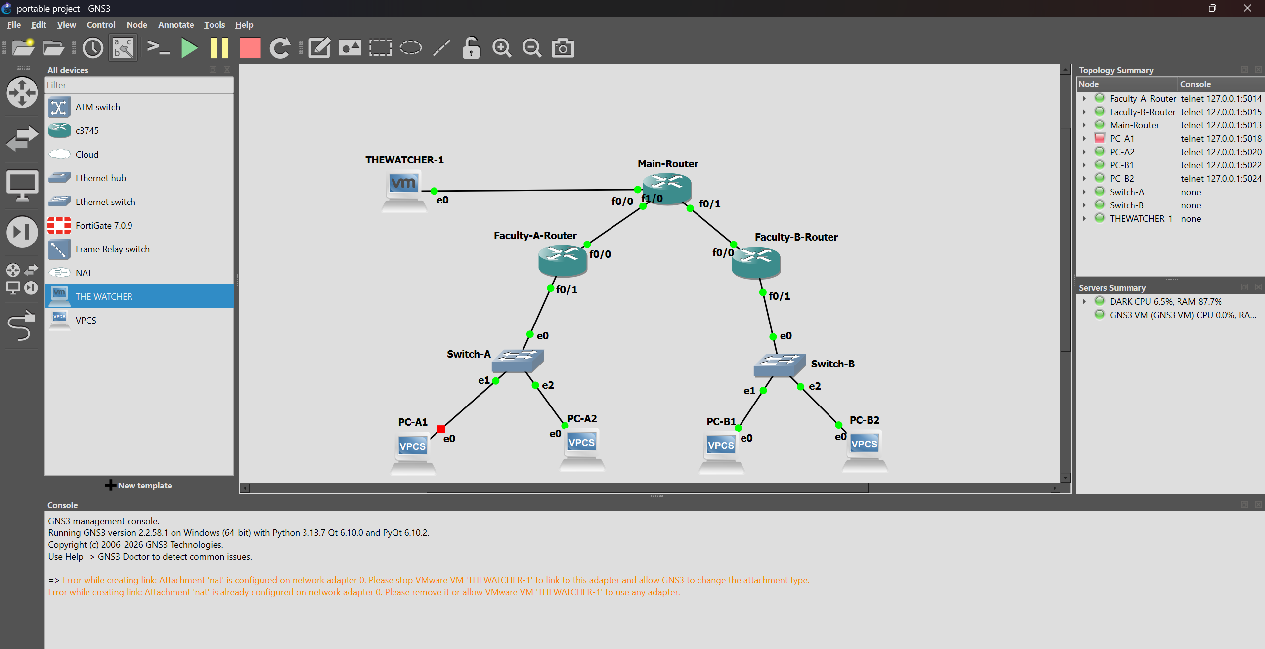
4- The dump problem of not saving the vpcs / routers, you should always type save after each ip giving or change on the routers .
5-The problem of time we just worked and we did a mistake and We relied on zabbix, and it take a lot of days just to try to solve the problems that comes from it so we goes with flask because of the time
6-VMnet adapters problems in this project so much of adapters problems we just hit because of the problem number 1, it was hard to fix but it gives us a better look at the adapters and we adapt to use it after some research
7- some times everything goes well you are sure everything is working you just follow this manual 100% correct and it does not work, then make sure of the point 6, make sure the gns3vm is seeing the vm by connecting the adapters they can’t have different ones
The improvements that we plan to make when we swtich to linux operating system :
1- make an authentication and more security for the webpage better log in system and creating accounts
2- when we can use switches instead of routers because of :
-Using routers instead of switches increases configuration complexity because routers operate at Layer 3.
- Switches are optimized for fast Layer 2 forwarding, while routers may introduce more processing overhead.
- Routers consume more resources compared to switches, especially when handling multiple interfaces.
-switches is always better for the VLANs
3- Using DHCP to give ip, and make the webpage automatically pinging them to see there status
4- add a login page that open anywhere so the student and doctors and tech support can have their websites that they can use

